Advanced Engineering Mathematics, by Erwin Kreyszig 10th. Ed.

**Problem Set 9.8**

No. 1

 



At point P,

No. 2

 



At point P,





No. 3









No. 4

 



No. 5

 



At point P,

No. 6













No. 7







Then 

No. 8







(a) or 

(b)

No. 9

Prove

(a)



(b)











(c)

 







 (1)

 (2)

From (1) and (2)  is proved.

(d) 

 



From(c)















 (2)

From (1) and (2)  is proved.

No. 10

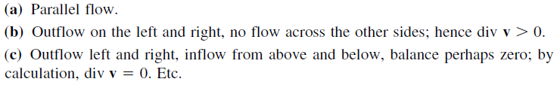

No. 11



The flow is incompressible.



The distance between the two parallel faces, x = 0 and x = 1 at t = 0, remains 1 at time t = 1

And since no velocity component along y and z axes, nothing happens in the y and z directions. The volume is still 1.

y

x

z

At t=0

No. 12



  

  

On the face x＝0

At t＝0, 

At t＝1, 

On the face y＝0

At t＝0, 

At t＝1, 

On the face z＝0

At t＝0, 

At t＝1, 

On the face x＝1

At t＝0, 

At t＝1, 

On the face y＝1 

On the face z＝1 

The initial volume(at t＝0) is 

After t＝1, the volume becomes 

No. 13





Since the fluid is incompressible, 

No. 14

No

No. 15













No. 16



















No. 17















No. 18









 





No. 19



























No. 20













